Architecture Design Document
for
VaagBanda
Smart Mobile Expense-Splitting Application

Version 1.0
Prepared by CyberSquadNp
Dongshin University
Glocal Autonomous Major College
May 2026
Design Phase – Architecture Design Document
Hybrid Pipe-and-Filter + Client-Server Architecture

Context Diagram
VaagBanda acts as the central expense-splitting system that communicates with multiple external services to support core application features.
The system integrates with:

- Authentication Service for secure user login and identity verification
- Push Notification Service for alerts, reminders, and activity updates
- Currency Exchange Service for real-time currency conversion
- Receipt Scanner Service for extracting expense information from receipts
- Settlement Recording Service for tracking completed payments between users
- Analytics & Report Export Service for generating spending analysis and reports

The context diagram focuses on external system interactions and system boundaries rather than internal database structure or implementation details.

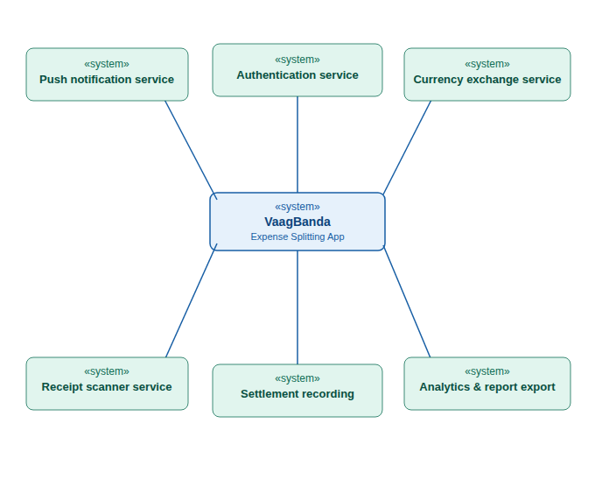

- System Architecture:
System architecture is the high-level structure of a system that defines its main components, how they are organized, and how they interact with each other. It provides a blueprint for designing and developing the system, ensuring that all parts work together efficiently. It also helps in managing complexity, improving scalability, and maintaining the system over time.

1.1 Client–Server Architecture:
Client–Server Architecture is a system design where clients (such as mobile apps) send requests to a central server, and the server processes those requests and returns responses. Communication between client and server happens over the Internet using protocols like HTTPS. The application server handles the main logic such as user login, expense management, and group operations, while the database server stores data like users and expenses. External services are integrated to provide additional features such as notifications and authentication (e.g., Face ID).

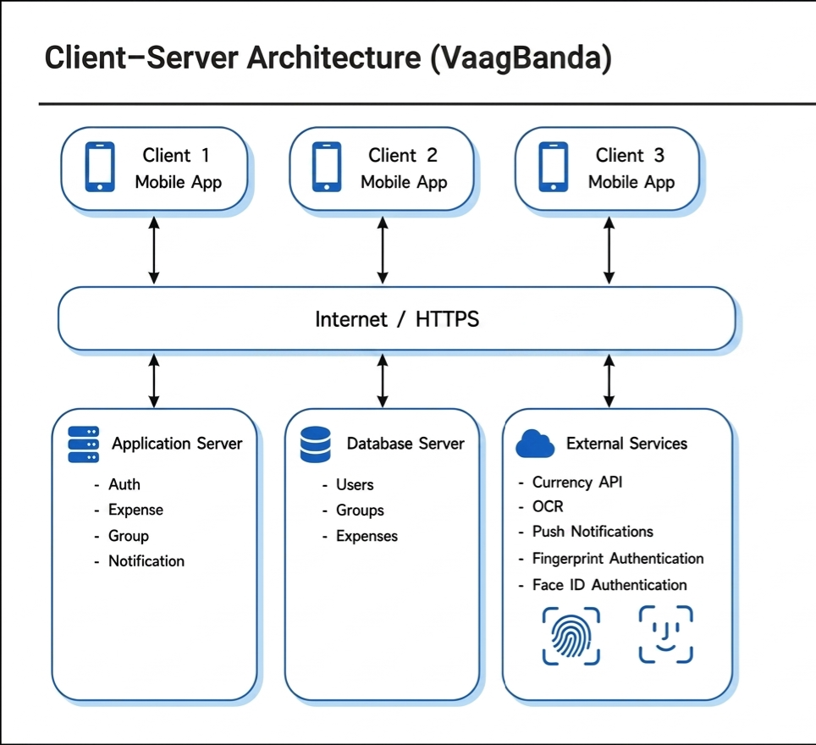

Name | Client–Server
Description | Clients send requests to the server, and the server processes and returns results.
Example | Mobile app where users add and share expenses.
When used | Used in web and mobile apps with many users.
Advantages | Easy to manage Supports many users Scalable
Disadvantages | Needs internet Server failure affects all Can be slow under heavy load

1.2 Pipe-and-Filter Architecture
Pipe-and-Filter Architecture is a design where data flows through a sequence of processing steps called filters. Each filter performs a specific task and passes its output to the next stage. In the server, the process starts with a client request and ends with a response sent back to the client. The request handler acts as the entry point, followed by validation to check input data, authentication to verify the user, and authorization to check permissions. Then, business logic processes the core operations, data access interacts with the database, and finally, the response formatter prepares the output (usually in JSON format).
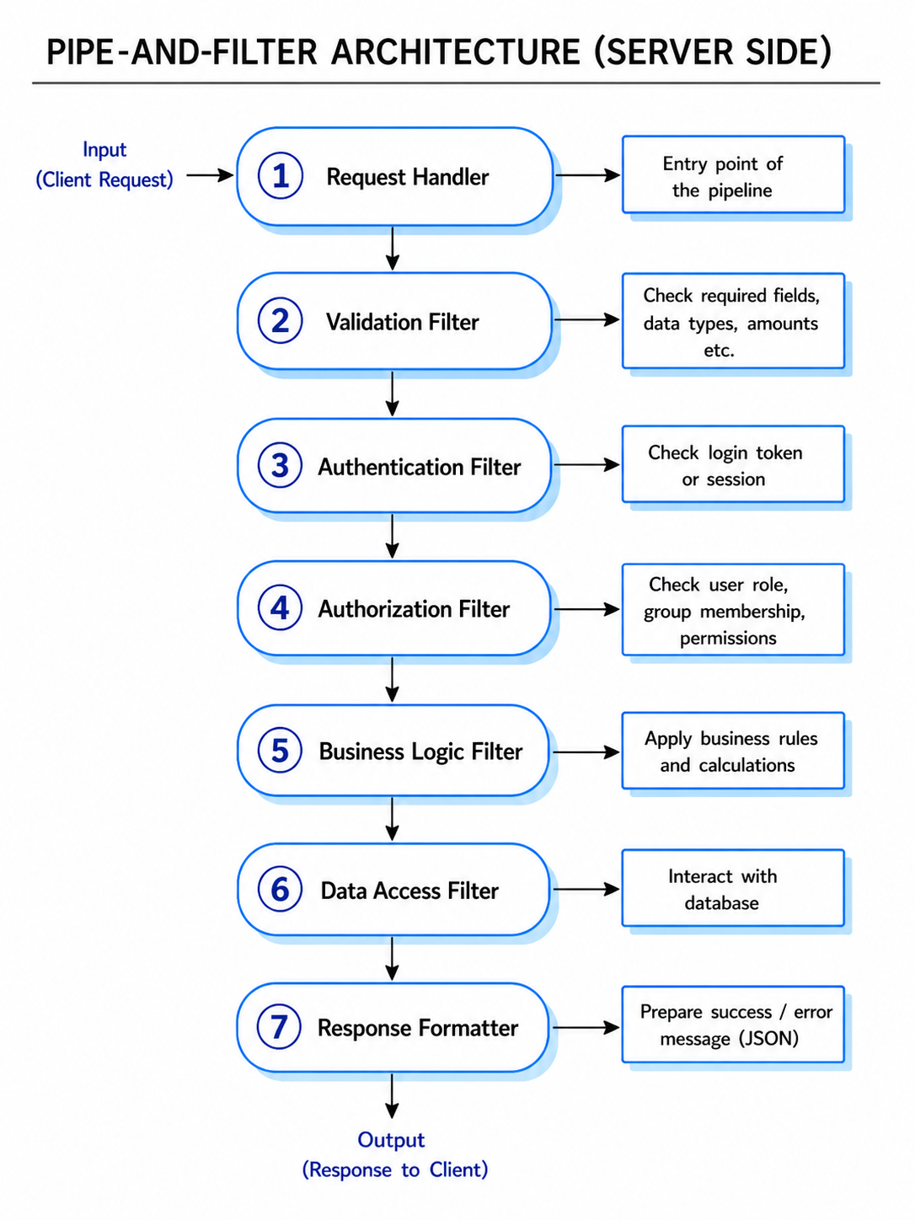

Name | Pipe-and-Filter
Description | Data is processed in a sequence of steps (filters), where each filter transforms input and passes it to the next through pipes.
Example | Server request processing: validation → authentication → authorization → business logic → database → response.
When used | Used in data processing systems and backend request pipelines.
Advantages | Simple and modular design
 | Easy to test and maintain
 | Reusable components
Disadvantages | Not suitable for interactive systems
 | Data format must be consistent
 | Can add processing overhead
Version_1_completed —

Mock up link (VaagBanda — Working Mockup v2)

MAIN FILE
Database design
Interface design
Component selection and design
Architectural design

